Organisation Legal Name – Royal Naval Association Torrevieja.
Organisation ID / Charity Number – 597132 & G54558820
Organisation Address – the address where we hold our monthly meetings is
Silverstone´s 2023 Av, Romero 03176, Montebello, Alicante
Organisation Contact Tel. / WhatsApp No- Point of Contact phone number is –
Carl Louden 678 518 202 and Nicola Louden 711 019 915.
Organisation Email – Point of Contact for this event email address is please send any pre-event information to both of these addressees
carllouden@msn.com or nicolajean@msn.com
Organisation Website – We do not have a dedicated Website
Organisation Logo – is below, the first is our standard logo and the second is one for the year Sep 25 to Sep 26 as we are celebrating being in existence for 35 years
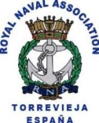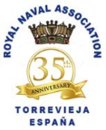

If you require anything further, please do not hesitate to contact us.

